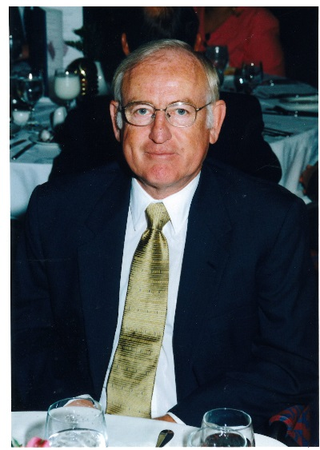

KEN HARRIS
- Graduated from Central Catholic High School in Portland
- University of Portland Graduate in 1960
- Twelve years teaching and head basketball coach at Churchill High School from 1968-1980
- Sunset High School Athletic Director from 1980-1996 and Head Boys Basketball Coach from 1980-2004
- 1987 State 4A Boys Basketball Champions
- Member of Oregon Athletic Directors Executive Board from 1984 – 1989
- President of the OADA 1987 –1988

